Provincial Psychosocial Services: Online Courses
The following course are offered by Provincial Psychosocial Services at no cost to the public. These courses are voluntary, and to provide learning opportunities to interested parties. They do not replace any training requirements for other organizations. Please note that you will not receive a certificate unless you request one directly from us by writing edu.pps@phsa.ca

These courses are some of the same ones our Disaster Psychosocial Support (DPS) team members take but please note if you are a new member of the DPS, you must take your courses through Learning Hub and will be provided that information during orientation. Doing this version of the courses is not sufficient and you will be asked to repeat the course in Learning Hub.

Courses

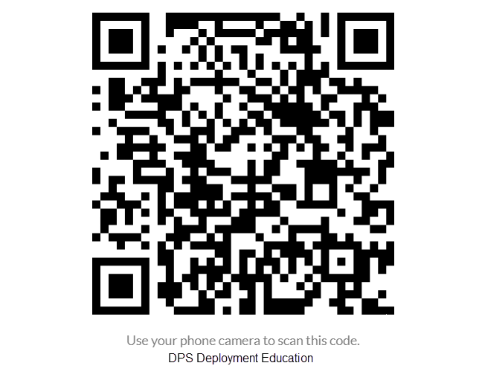  Or click: DPS Deployment Education | 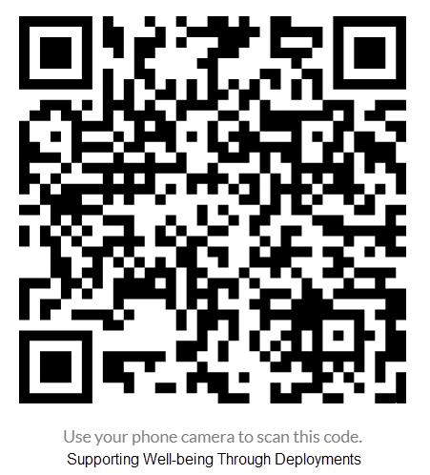  Or Click: Supporting Well-being Through Deployments
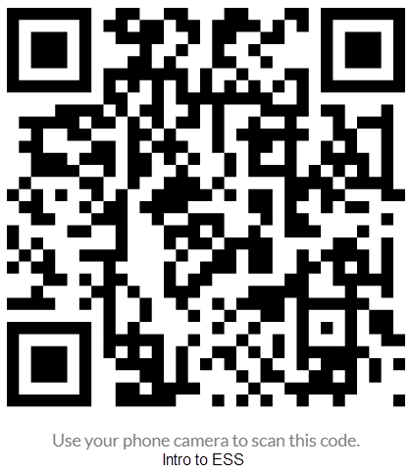  Or click: Intro to ESS | 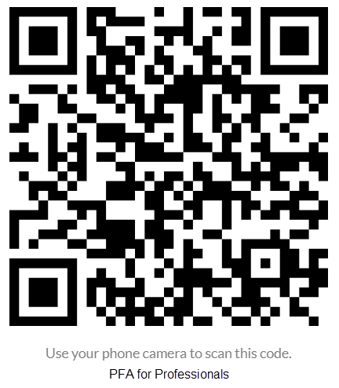  Or click: Psychological First Aid for Professionals

