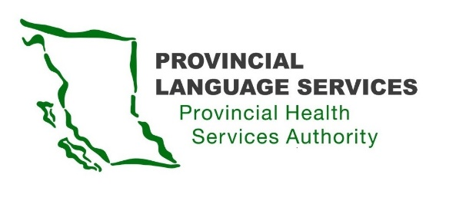

MINUTES | Community Advisory Group | Meeting 2
13 December 2020

Meeting 10 am – 1 pm
Location: Willingdon Office & IMITS Meeting Platform

Present: Monika Lane (Vancouver Island), Nancy Zavaglia (Prince George), Leanor Vlug (Lower Mainland), Dan Braun (Lower Mainland), Craig MacLean (Lower Mainland), Sarah Taylor (Lower Mainland), Gordon Rattray (Kelowna), Kiran Malli (Provincial Language Services)
Facilitator: Emina Dervisevic (Delaney +Associates)
Note Taker: Brittany Mason (Delaney +Associates)
- Welcome
Welcome from Kiran Malli, Director, Provincial Language Services
Discussion about meeting format: regular, short breaks to be taken.
- Operating Values
- Respect is our guiding light.
- We will take a community-wide view for our recommendations.
- We will think about everyone - birth to death, and not prioritize one age group.
- We will respect privacy and confidentiality of information – everyone needs to feel safe, including the interpreters.
- The work of the Community Advisory Group needs to be as transparent as possible.
- We will ensure there is easy and accessible communication that is equitable and clear.
- We will respect that relying on technology is not great for the Deaf-Blind community.
- We will provide all materials in a Deaf-Blind-friendly format – all fonts as18pt Arial.
- We will send agenda and all other materials in a Word format in advance so that Community Advisory Group (CAG) members have time to review them.

- Discussion about the importance of providing support to interpreters as well as advisory group members:
  - Give them the choice to work at an advisory group session
  - Provide support if they feel uncomfortable from working at the advisory group (through Kiran Malli or facilitator
  - It is important that everyone feels safe.
- Review CAG Meeting #1 Minutes
- Discussion about the difference between the terms “Deaf” and “deaf” and the importance of the note-taker understanding this
- Discussion about using the terms “racialized” and “person of colour”
Action Item: Emina to update notes from previous meeting.
Action Item: Kiran to upload notes.
Action Item: Group to use “Deaf”, “Deaf-Blind”, and “Hard of Hearing” in all writing, in the future
Overview of Provincial Language Services, Medical Interpreting Services, and Engagement
- Overview of Provincial Language Services: Provincial Language Services provides services to health care across the province – mainly health authorities but have started doing phone interpreting for General Practitioner (GP) offices
  - Provincial Language Services serves 3 of the 4 language constituents in Canada: Minority Language (Francophone in British Columbia), Immigrant and Refugee Languages, Deaf and Hard of Hearing.
  - Currently looking into providing Indigenous Languages
  - Provide interpreting (oral) and translation (written)
  - Access to over 200 languages over the phone, around 40 in person
- Discussion about expanding services to Deaf immigrants and refuges in the future, having Quebec Sign Language (LSQ) availability
- Overview of engagement to-date: Provincial Language Services undertook an engagement process with the Deaf/Deaf-Blind/hard of hearing community in 2017
  - It was clear more engagement was needed
  - Travelled to 5 communities across the province
- Discussion about the importance of transparency and the importance of all advisory group members feeling safe.
- Review of Draft Terms of Reference
- Confirm that missing 3 meetings will lead to a member being asked to step down: to make sure the work of the advisory group continues and that members can be relieved if unable to commit
  - Important to maintain diversity, so if a member leaves and is a member of a certain minority group, they should be replaced by someone from the same, to maintain representation
  - A committee will be formed if there is need for a new member
- Replace the word “Skype” with “video”
- Meeting notes will be posted 10 days after the following meeting to allow time for review by the group
Action Item: Emina to share the Terms of Reference with updated Values/Service Goals and Operating Values.
- Job Description
Discussion of job description requirements

Action Item: Kiran to make suggested changes to job description.
- Request for Proposal Components

Discussion of Request for Proposal components
Action Item: Emina to collect further input on Request for Proposal, distribute what has been heard

